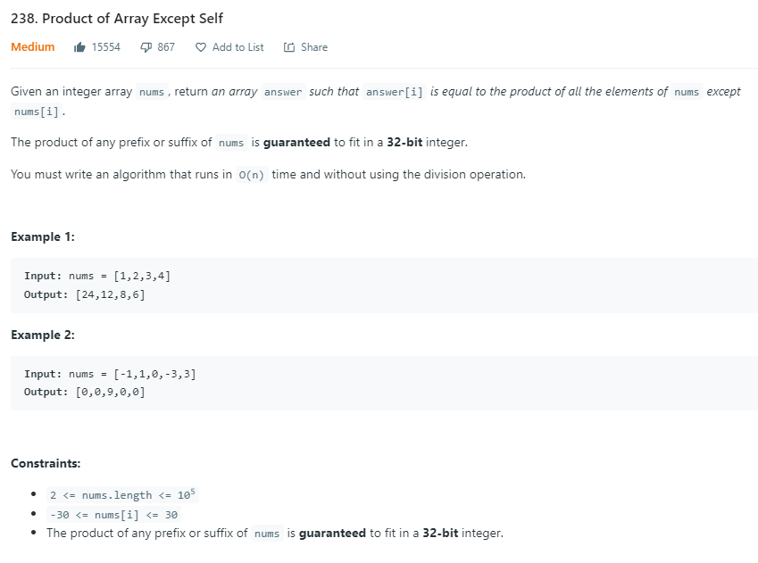

**Solution:**

class Solution:

    def productExceptSelf(self, nums: List[int]) -> List[int]:

        result = [1] * len(nums)

        prefix = 1

        for i in range(len(nums)):

            result[i] = prefix

            prefix *= nums[i]

        postfix = 1

        for i in range(len(nums)-1,-1,-1):

            result[i] *= postfix

            postfix *= nums[i]

        return result

demo = Solution()

demo.productExceptSelf([1,2,3,4])

**Output:**

[24, 12, 8, 6]

**Time Complexity:** O(2n) 🡪 O(n)

**Space Complexity:** O(1)